Copy paste
5.2.4 Risk Analysis
Risk analysis examines the dangers posed by natural and human-caused events to the assets of an organization. A user performs an asset identification to help determine which assets to protect.
A risk analysis has four goals:
- Identify assets and their value.
- Identify vulnerabilities and threats.
- Quantify the probability and impact of the identified threats.
- Balance the impact of the threat against the cost of the countermeasure.
Scroll down to learn more about the two approaches to risk analysis.
Quantitative risk analysis
A quantitative risk analysis assigns numbers to the risk analysis process. In this example, the asset value is the replacement cost of the file server (the asset). The value of an asset can also be measured by the income gained through the use of the asset.
The exposure factor (EF) is a subjective value expressed as a percentage of the file server lost due to a particular threat. If total loss occurs, the EF equals 1.0 (100%).
The annualized rate of occurrence (ARO) is the probability that a loss will occur during the year. An ARO can be greater than 100% if a loss can occur more than once a year.
The calculation of the annual loss expectancy (ALE) gives management some guidance on what an organization should spend to protect the file server.
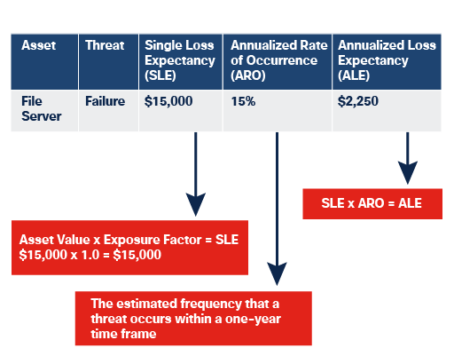
Qualitative risk analysis
Qualitative risk analysis uses opinions and scenarios plotting the likelihood of a threat against its impact. For example, a server failure may be likely, but its impact may only be marginal.
A risk matrix is a tool that helps prioritize risks to determine which ones the organization needs to develop a response for. The results can be ranked and used as a guide to determine whether the organization takes any action.
When the risk matrix is color-coded, as shown here, it is referred to as a risk heat map.
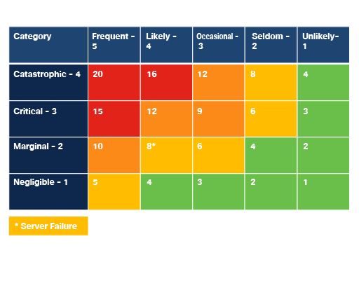

5.2.5 Lab Video - Risk Analysis
Press the play button to view this short demo video.
5.2.6 Lab - Risk Analysis
In this Lab, you will meet the following objectives:
- Part 1: Use Risk Analysis Methods
- Part 2: Calculate Risks
descriptionLab - Risk Analysis
5.2.7 Risk Mitigation
Mitigation involves reducing the likelihood or severity of a loss from threats. Many technical controls mitigate risk, including authentication systems, file permissions and firewalls.
Organizations must understand that risk mitigation can have both positive and negative impacts on the organization. Good risk mitigation finds a balance between the negative impact of countermeasures and controls and the benefit of risk reduction.
Select the headings for more information on the most common ways to mitigate against risk.
expand_less
Accept the risk and periodically reassess
A short-term strategy is to accept the risk necessitating the creation of contingency plans for that risk. People and organizations have to accept risk on a daily basis.
expand_less
Reduce the risk by implementing controls
Modern methodologies reduce risk by developing software incrementally, and by providing regular updates and patches to address vulnerabilities and misconfigurations.
expand_less
Avoid the risk by totally changing the approach
A good risk mitigation plan can include two or more strategies.
expand_less
Transfer the risk to a third party
Outsourcing services, purchasing insurance and purchasing maintenance contracts are all examples of risk transfer. Hiring specialists to perform critical tasks to reduce risk can be a good decision and yield greater results with less long-term investment.

Chatgpt

5.2.4 Risk Analysis
Risk analysis studies how different threats — natural or human-made — can affect an organization’s assets. Before analyzing risks, organizations first identify their important assets, such as servers, databases, or applications.
A risk analysis focuses on four main goals:
- Identify important assets and determine their value.
- Identify possible threats and vulnerabilities affecting those assets.
- Estimate how likely those threats are and how much damage they could cause.
- Compare the damage cost with the cost of protecting against it.

Quantitative Risk Analysis
Quantitative risk analysis uses numerical values and calculations to estimate risk.
For example, consider a file server worth $15,000.
The Exposure Factor (EF) represents how much of the asset could be lost from a specific threat.
- EF = 1.0 means total loss (100% damage).
The Annualized Rate of Occurrence (ARO) estimates how often the threat may happen in one year.
- An ARO of 15% means the organization expects the event roughly 0.15 times per year.
The Single Loss Expectancy (SLE) calculates the loss from one incident.
SLE = Asset\ Value \times Exposure\ Factor
Example:
15000 \times 1 = 15000
The Annual Loss Expectancy (ALE) estimates yearly loss.
ALE = SLE \times ARO
Example:
15000 \times 0.15 = 2250
This helps management decide how much money is reasonable to spend on protection.

Qualitative Risk Analysis
Qualitative risk analysis relies more on judgment, experience, and scenario-based evaluation than exact numbers.
For example:
- a server crash may happen often,
- but the business impact may be small.
Organizations commonly use a risk matrix to compare:
- likelihood of the threat,
- impact of the threat.
This helps prioritize which risks need attention first.
When the matrix uses colors like green, yellow, and red, it is called a risk heat map.

5.2.7 Risk Mitigation
Risk mitigation means reducing either:
- the chance of a threat happening,
- or the damage caused if it happens.
Common security controls used for mitigation include:
- firewalls,
- authentication systems,
- access permissions.
Organizations also consider the side effects of security controls. Good mitigation balances security benefits with cost, complexity, and usability.

Accept the Risk and Periodically Reassess
Sometimes organizations knowingly accept a risk temporarily and prepare contingency plans if the issue occurs.
Example:
- continuing to use an old system until replacement is affordable.
Risk acceptance is common in daily business decisions.

Reduce the Risk by Implementing Controls
Organizations lower risk by improving security controls and regularly updating systems.
Examples:
- installing patches,
- updating software,
- fixing misconfigurations.
Modern development practices also reduce risk through frequent updates and incremental improvements.

Avoid the Risk by Totally Changing the Approach
Risk can sometimes be avoided completely by changing how something is done.
Example:
- removing an insecure application instead of trying to secure it.
Many mitigation plans combine multiple strategies together.

Transfer the Risk to a Third Party
Organizations may shift risk to another party instead of handling it directly.
Examples include:
- cyber insurance,
- outsourcing services,
- maintenance contracts.
Hiring specialists for critical operations can reduce internal risk and improve results.

